# CHAPTER 3

**PROPOSE IMPLEMENTATION**

* 1. **PROBLEM STATEMENT**

Automation of a device has a wide scope for this Generation as well as in forthcoming generation. In this wide scope, Mobile communication technology is playing a major role in the world of automation. This article is fully based on low cost and reliable home control monitoring system for accessing and controlling devices and appliances remotely using Android based Smart phone application.

While using this technology the system improves:

* The living standard at home
* Reduces human effort
* Energy efficient
* Time saving

Thus make a smart home and also it was very helpful for providing support to disabled people and fulfil their needs in home and thus they lead a normal life. The proposed systems consist of android mobile, Arduino Uno board, Wi-Fi module and a relay circuit.

We are using Wi-Fi technology to monitor the device because of its accuracy, high range and instant connectivity. This module controls the home appliances with a very ease of installation and it is user friendly.

* 1. **SOFTWARE REQUIREMENT**
     1. **Arduino Software (IDE)**

The open-source Arduino Software (IDE) makes it easy to write code and upload it to the board. This software can be used with any Arduino board.

Arduino is an open-source electronics platform based on easy-to-use hardware and software. Arduino boards are able to read inputs - light on a sensor, a finger on a button, or a Twitter message - and turn it into an output - activating a motor, turning on an LED, publishing something online. You can tell your board what to do by sending a set of instructions to the microcontroller on the board. To do so you use the Arduino programming language (based on Wiring), and the Arduino Software (IDE), based on Processing.

* + 1. **Blynk**

Blynk was designed for the Internet of Things. It can control hardware remotely, it can display sensor data, it can store data, vizualize it and do many other cool things. There are three major components in the platform:

1. **Blynk App** -allows to you create amazing interfaces for your projects using various widgets we provide.
2. **Blynk Server** - responsible for all the communications between the smartphone and hardware. You can use our Blynk Cloud or run your private Blynk server locally. It’s open-source, could easily handle thousands of devices and can even be launched on a Raspberry Pi.
3. **Blynk Libraries** - for all the popular hardware platforms - enable communication with the server and process all the incoming and outcoming commands.
   1. **HARDWARE REQUIREMENT**
      1. **ESP-32**

ESP32-WROVER is a powerful, generic WIFI-BT-BLE MCU module that targets a wide variety of applications, ranging from low-power sensor networks to the most demanding tasks, such as voice encoding, music streaming and MP3 decoding.

This module is provided in two versions: one with a PCB antenna, the other with an IPEX antenna. ESP32-WROVER features a 4 MB external SPI flash and an additional 8 MB SPI Pseudo static RAM (PSRAM).

The ordering information on the two variants of ESP32-WROVER is listed as follows:

|  |  |  |  |  |
| --- | --- | --- | --- | --- |
| Module | Chip embedded | Flash | PSRAM | Dimensions (mm) |
| ESP32-WROVER (PCB) | ESP32-D0WDQ6 | 4 MB | 8 MB | (18.00±0.10)×(31.40±0.10)×(3.30±0.10) |
| ESP32-WROVER (IPEX) |

Table 1: ESP32­WROVER Ordering Information

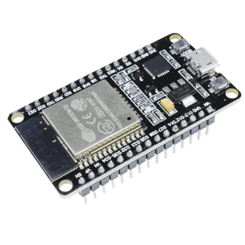

**Fig1. ESP32**

* + 1. **8-Channel Relay**

The eight-channel relay module contains eight 5V relays and the associated switching and isolating components, which makes interfacing with a microcontroller or sensor easy with minimum components and connections. There are eight terminal blocks with six terminals each, and each block is shared by two relays. The terminals are screw type, which makes connections to mains wiring easy and changeable.

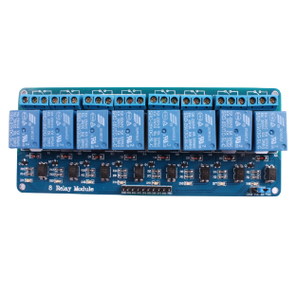

**Fig2. 8-Channel Relay**

* + 1. **Bread Board**

A breadboard is a solderless device for temporary prototype with electronics and test circuit designs. Most electronic components in electronic circuits can be interconnected by inserting their leads or terminals into the holes and then making connections through wires where appropriate. The breadboard has strips of metal underneath the board and connect the holes on the top of the board. The metal strips are laid out as shown below. Note that the top and bottom rows of holes are connected horizontally and split in the middle while the remaining holes are connected vertically.

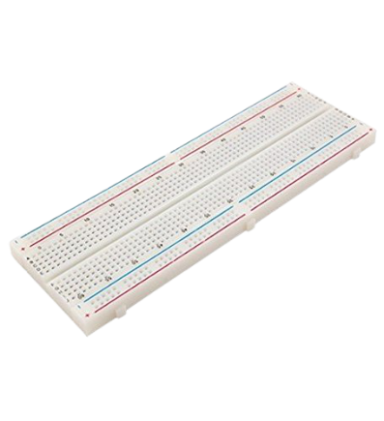

**Fig3. Bread Board**

* + 1. **Jumper Wires**

Jumper wires are simply wires that have connector pins at each end, allowing them to be used to connect two points to each other without soldering. Jumper wires are typically used with breadboards and other prototyping tools in order to make it easy to change a circuit as needed.

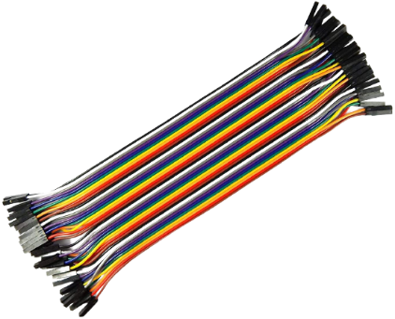

**Fig4. Jumper Wires**

* + 1. **Regulator Switch**

A switching regulator is a voltage regulator that uses a switching element to transform the incoming power supply into a pulsed voltage, which is then smoothed using capacitors, inductors, and other elements.

Power is supplied from the input to the output by turning ON a switch (MOSFET) until the desired voltage is reached.

Once the output voltage reaches the predetermined value the switch element is turned OFF and no input power is consumed.

Repeating this operation at high speeds makes it possible to supply voltage efficiently and with less heat generation.

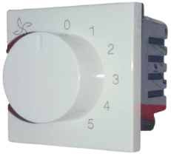

**Fig5. Regulator Switch**

* + 1. **Prototype Board / Pref-Board**

Perf-board is a material for prototyping electronic circuits (also called DOT PCB). It is a thin, rigid sheet with holes pre-drilled at standard intervals across a grid, usually a square grid of 0.1 inches (2.54 mm) spacing. These holes are ringed by round or square copper pads, though bare boards are also available. Inexpensive perfboard may have pads on only one side of the board, while better quality perfboard can have pads on both sides (plate-through holes). Since each pad is electrically isolated, the builder makes all connections with either wire wrap or miniature point to point wiring techniques. Discrete components are soldered to the prototype board such as resistors, capacitors, and integrated circuits. The substrate is typically made of paper laminated with phenolic resin (such as FR-2) or a fiberglass-reinforced epoxy laminate (FR-4).

Once the layout is finalized, the components are soldered in their designated locations, paying attention to orientation of polarized parts such as electrolytic capacitors, diodes, and integrated circuits. Next, electrical connections are made as called for in the layout.

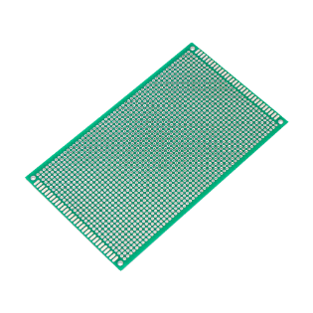

**Fig6. Prototype Board**

* + 1. **Resistor**

A passive electrical component with two terminals that are used for either limiting or regulating the flow of electric current in electrical circuits.

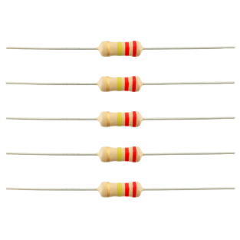

**Fig7. Resistors**

* + 1. **Capacitor**

A device used to store an electric charge, consisting of one or more pairs of conductors separated by an insulator.

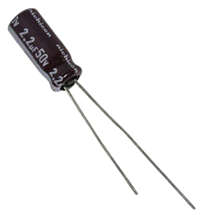

**Fig8. Capacitor**

* + 1. **Light Bulb**

A glass bulb or tube that produces light when it is supplied with electricity

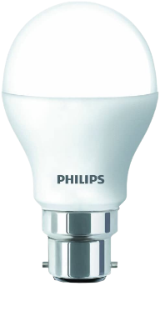

**Fig9. Light Bulb**

* 1. **PROJECT REQUIREMENT**
     1. **Software Requirement**
* Operating System: Windows 7,8,10.
* Front End: HTML, CSS, JavaScript.
* Back End: C, C++.
* Server management: Blynk.

1. **Hyper Text Markup Language: (HTML)**

Hypertext Markup Language (HTML) is the standard markup language for documents designed to be displayed in a web browser. It can be assisted by technologies such as Cascading Style Sheets (CSS) and scripting languages such as JavaScript. Web browsers receive HTML documents from a web server or from local storage and show the documents into multimedia web pages. HTML describes the structure of a web page semantically and originally included cues for the appearance of the document. HTML provides a means to create structured documents by denoting structural semantics for text such as headings, paragraphs, lists, links, quotes and other items. By this, with HTML you can create your own Website.

1. **Cascading Style Sheet (CSS)**

Cascading Style Sheets (CSS) is a style sheet language used for describing the presentation of a document written in a markup language like HTML. CSS is designed to enable the separation of presentation and content, including layout, colors, and fonts. This separation can improve content accessibility, provide more flexibility and control in the specification of presentation characteristics, enable multiple web pages to share formatting by specifying the relevant CSS in a separate .css file, and reduce complexity and repetition in the structural content. Separation of formatting and content also makes it feasible to present the same markup page in different styles for different rendering methods, such as on-screen, in print, by voice and on Braille-based tactile devices. CSS also has rules for alternate formatting if the content is accessed on a mobile device. The name cascading comes from the specified priority scheme to determine which style rule applies if more than one rule matches a particular element. This cascading priority scheme is predictable. In addition to HTML, other markup languages support the use of CSS including XHTML, plain XML

1. **JavaScript: (JS)**

JavaScript often abbreviated as JS, is an interpreted programming language. JavaScript is high-level, often just-in-time compiled, and multi-paradigm. It has curly- bracket syntax, dynamic typing, prototype-based object-orientation, and first-class functions. Alongside HTML and CSS, JavaScript is one of the core technologies of the World Wide Web. JavaScript enables interactive web pages and is an essential part of web applications. The vast majority of websites use it for client-side page behavior, and all major web browsers have a dedicated JavaScript engine to execute it. As a multi-paradigm language, JavaScript supports event-driven, functional, and imperative programming styles. Originally used only in web browsers, JavaScript engines are also now embedded in server-side website deployments and non-browser applications. Although there are similarities between JavaScript and Java, including language name, syntax, and respective standard libraries, the two languages are distinct and differ greatly in design.

1. **C Language**

C is a procedural programming language. It was initially developed by Dennis Ritchie as a system programming language to write operating system. The main features of C language include low-level access to memory, simple set of keywords, and clean style, these features make C language suitable for system programming like operating system or compiler development.

1. **C++ Language**

C++ is an advanced version of C procedural programming language.

* 1. **ADVANTAGES**

The In recent years, wireless systems like Wi-Fi have become more and more common in-home networking. Also, in home and building automation systems, the use of wireless technologies gives several advantages that could not be achieved using a wired network only.

1. **Reduced installation costs:** First and foremost, installation costs are significantly reduced since no cabling is necessary. Wired solutions require cabling, where material as well as the professional laying of cables (e.g., into walls) is expensive.
2. **System scalability and easy extension:** Deploying a wireless network is especially advantageous when, due to new or changed requirements, extension of the network is necessary. In contrast to wired installations, in which cabling extension is tedious. This makes wireless installations a seminal investment.
3. **Aesthetical benefits:** Apart from covering a larger area, this attribute helps to full aesthetical requirements as well. Examples include representative budings with all-glass architecture and historical budings where design or conservatory reasons do not allow laying of cables.
4. **Integration of mobile devices:** With wireless networks, associating mobile devices such as PDAs and Smartphones with the automation system becomes possible everywhere and at any time, as a device's exact physical location is no longer crucial for a connection (as long as the device is in reach of the network).

For all these reasons, wireless technology is not only an attractive choice in renovation and refurbishment, but also for new installations.

* 1. **APPLICATIONS**

Following are some applications of Home Automation System:

* Lighting control.
* HVAC Regulation: No Longer Burned by Your Heating Bill
* Smart home appliances.
* Improved home safety and security.
* Home air quality and water quality monitoring.
* Natural language-based voice assistants.